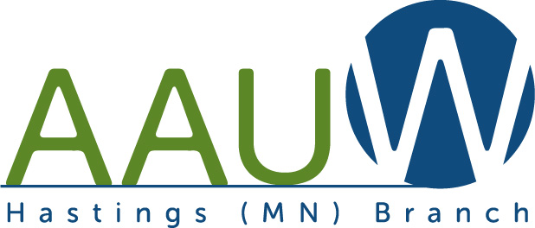

American Association of University Women
AAUW Mission Statement… AAUW advances equity for women and girls through advocacy, education, philanthropy, and research.
February 1, 2015
Name
Address

Dear ,
We are very happy to inform you that you have been selected by the AAUW Hastings Branch and AAUW of Minnesota to receive a scholarship to NCCWSL (National Conference of College Women Student Leaders). This scholarship was established to recognize outstanding college women and to connect them with a powerful network of women leaders. The award value, along with information about your scholarship, is provided below.
To receive this scholarship, we ask that you complete two tasks. First, after attending the convention, please send a thank you letter and a written report to AAUW of Minnesota. Second, please send a thank you letter to AAUW Hastings. We are interested in hearing about you, your academic plans, activities and career goals, as well as what the NCCWSL scholarship and the convention meant to you. We would also appreciate receiving pictures of your time at the conference. In the future, we would welcome the opportunity to hear about your experiences at an AAUW Hastings Branch meeting.
We believe you are making a difference in the world. Congratulations and best wishes for a productive and successful academic year!
Sincerely,

NCCWSL Selection Committee Chair
AAUW Hastings Branch

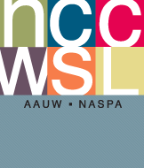
NCCWSL May 28–30, 2015
1. Scholarship Value: $500
Write Thank You to: AAUW of Minnesota/Sharon Bigot–aebskfb@comcast.net
2. Scholarship Value: $350
Write Thank You to: AAUW Hastings Branch
Both letters along with pictures may be sent to:
Email:

