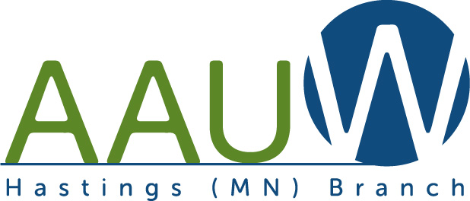

American Association of University Women
AAUW Mission Statement… AAUW advances equity for women and girls through advocacy, education, philanthropy, and research.
February 1, 2015
Name
Address

Dear ,
We appreciate receiving your application for the NCCWSL (National Conference for College Women Student Leaders) scholarship offered by AAUW of Minnesota and AAUW Hastings. Although you were not selected for the scholarship, we want you to know that you were one of six outstanding candidates, and that the final decision was very difficult. We encourage you to apply again next year.
Thank you for applying for this scholarship to NCCWSL 2015. Our AAUW Hastings Branch members send their best wishes to you for a productive and successful academic year.
Sincerely,
AAUW Hastings Branch

NCCWSL May 28–30, 2015
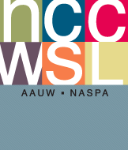
Email:

