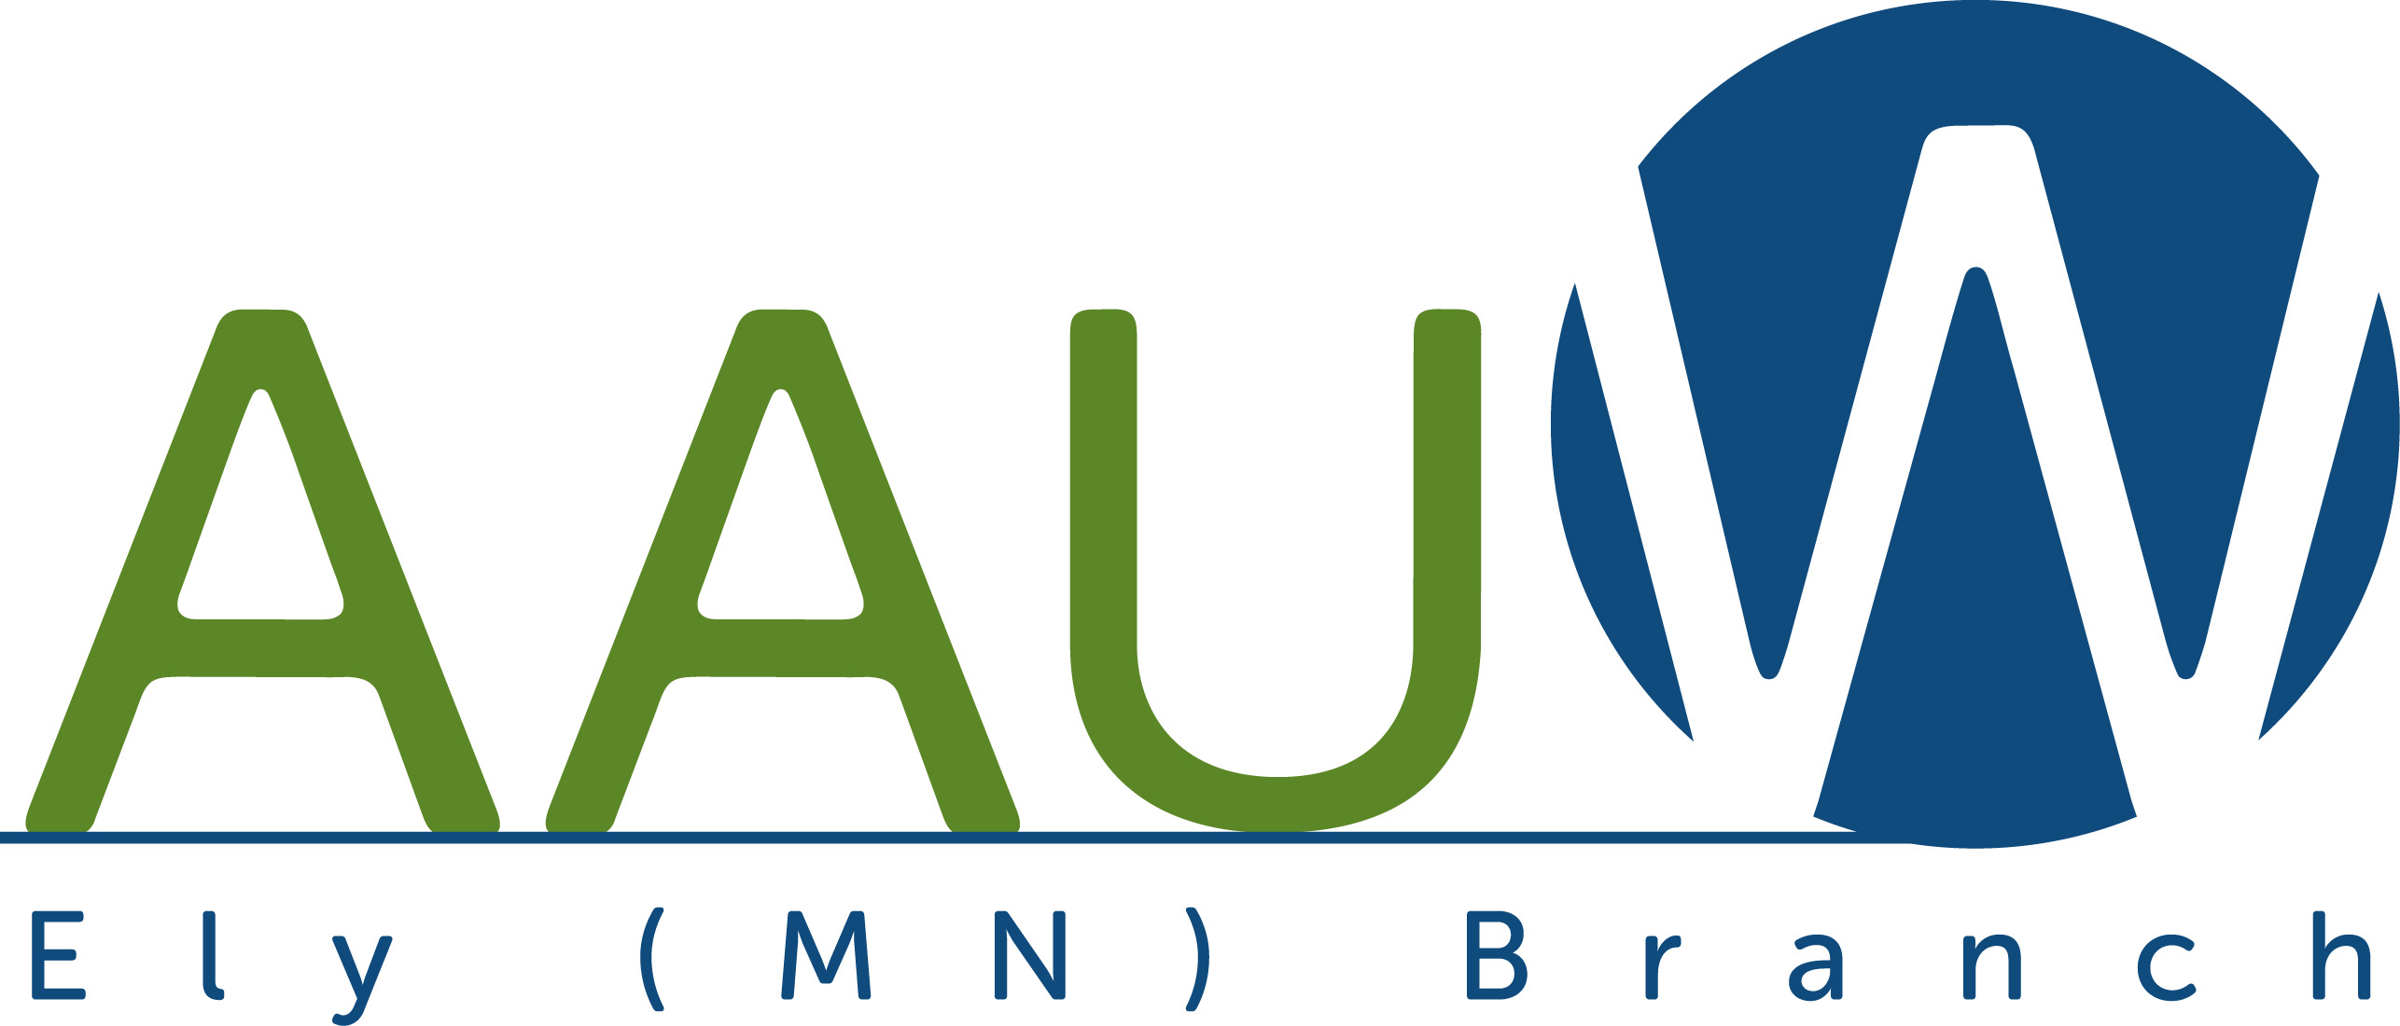

Membership Form

Join online by clicking the following link: Login - AAUW
(Make sure you select Ely branch member and not National member when prompted.)

Or fill out this form and mail with a check to our treasurer (address is below).

New or renewing member - $88/year $______
(National dues - $72 of which $69 is tax deductible, the remaining $3
is not tax deductible and will go to support AAUW Action Fund’s
501(c)(4) activities; State dues $9, Local dues $7)

Optional donation to branch $______

Total $______

Name:
Address:
Phone:
Email:
College/University:
Highest Degree Earned:
Graduation MM/YY:

Please mail your check payable to AAUW Ely Branch to:
Eva Stevens
650 Riverview Rd
Ely, MN 55731

