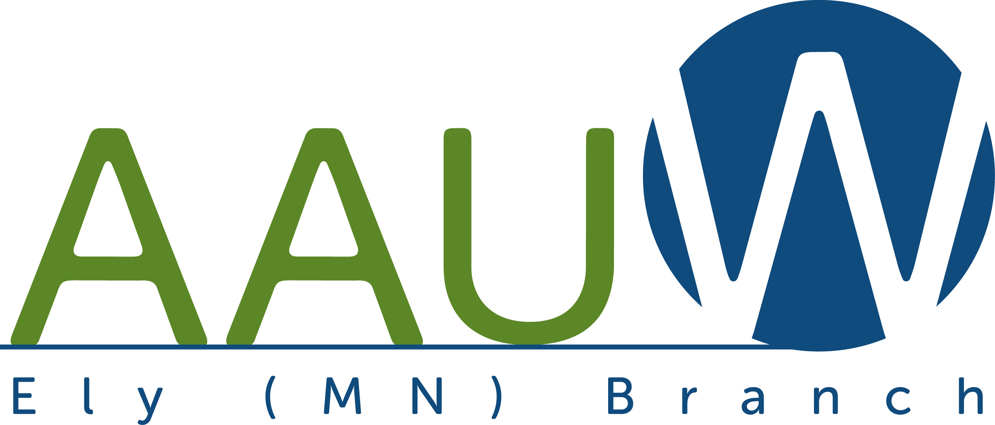

Membership Form

Join online by clicking the following link: Login - AAUW
(Make sure you select Ely branch member and not National member when prompted.)

Or fill out this form and mail with a check to our treasurer (address is below).

New or renewing member - $88/year $______
(National dues - $72 is tax deductible
State dues - $9 is tax deductible, Local dues- $7 is not tax deductible)

Optional donation to branch (Donations to Branch are not tax deductible.) $______

Total $______

Name:
Address:
Phone:
Email:
College/University:
Highest Degree Earned:
Graduation MM/YY:
Please mail your check payable to AAUW Ely Branch to:
Eva Stevens
650 Riverview Rd
Ely, MN 55731

AAUW Ely is a 501c4 organization. Dues and donations to the branch are not tax deductible.

